DAY 7 -> 19-05-2026
Project 1: Customer Churn Prediction & Lifetime Value (LTV) Engine
Data Preprocessing & Feature Engineering Continuation
DONE BY -> ANANTHARAJAN V B

1) Converting TotalCharges into Numeric Datatype
Description:
This method is used to convert the TotalCharges column from object datatype into numeric datatype for preprocessing and machine learning operations. Initially, the column was stored as text because hidden blank spaces and invalid values were present in the dataset. Blank spaces were replaced with null values before conversion to avoid datatype errors. Converting the feature into numeric format allows accurate statistical analysis and improves compatibility with machine learning algorithms.

FORMULA USED
filepath["TotalCharges"] = filepath["TotalCharges"].replace(" ", np.nan)
filepath["TotalCharges"] = pd.to_numeric(filepath["TotalCharges"])

SCREENSHOT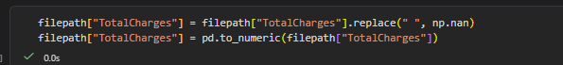

2) Datatype Validation After Conversion
Description:
This method is used to verify whether the TotalCharges column was successfully converted into numeric datatype after preprocessing.
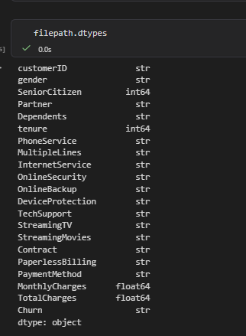

3) Encoding Target Column (Churn)
Description:
This method is used to transform the target variable Churn from categorical format into binary numerical format. The values Yes and No were converted into 1 and 0 respectively for classification modeling purposes. Machine learning classification algorithms cannot directly process textual labels, so encoding is required before training predictive models. This step prepares the churn feature for supervised machine learning analysis.

Formula used-> filepath["Churn"] = filepath["Churn"].map({"Yes":1, "No":0})

SCREENSHOT

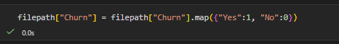

4) Encoding Binary Categorical Features
Description:
This method is used to convert binary categorical features into machine-readable numerical values using Label Encoding. Features such as gender, Partner, Dependents, PhoneService, and PaperlessBilling contain categorical values that cannot be directly processed by machine learning models.

FORMULA USED ->
for col in binary_cols:
filepath[col] = LabelEncoder().fit_transform(filepath[col])

SCREENSHOT
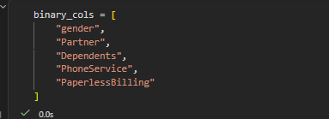

5) Final Dataset Verification
Description:
This method is used to validate the final structure and quality of the dataset after completing preprocessing and encoding operations. The verification process checks datatypes, encoded values, non-null counts, and overall dataset consistency before moving into feature engineering and machine learning stages. This step confirms that preprocessing tasks were successfully completed without introducing errors into the dataset.

FORMULA
filepath.head()
filepath.info()

SCREENSHOTS
